# Lab: Responsive-Design

Problems for exercises and homework for the “HTML and CSS” course @ SoftUni. Submit your solutions in the SoftUni judge system at <https://judge.softuni.bg/Contests/411/Lab-Responsive-Design> .

## Flexbox Order

Create a Web page (HTML5 + CSS3 + images) that looks and behaves like the screenshots below:

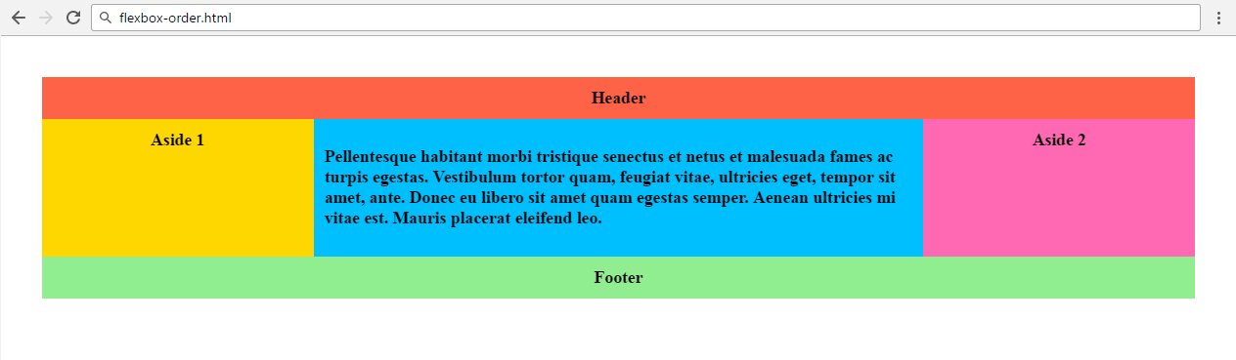

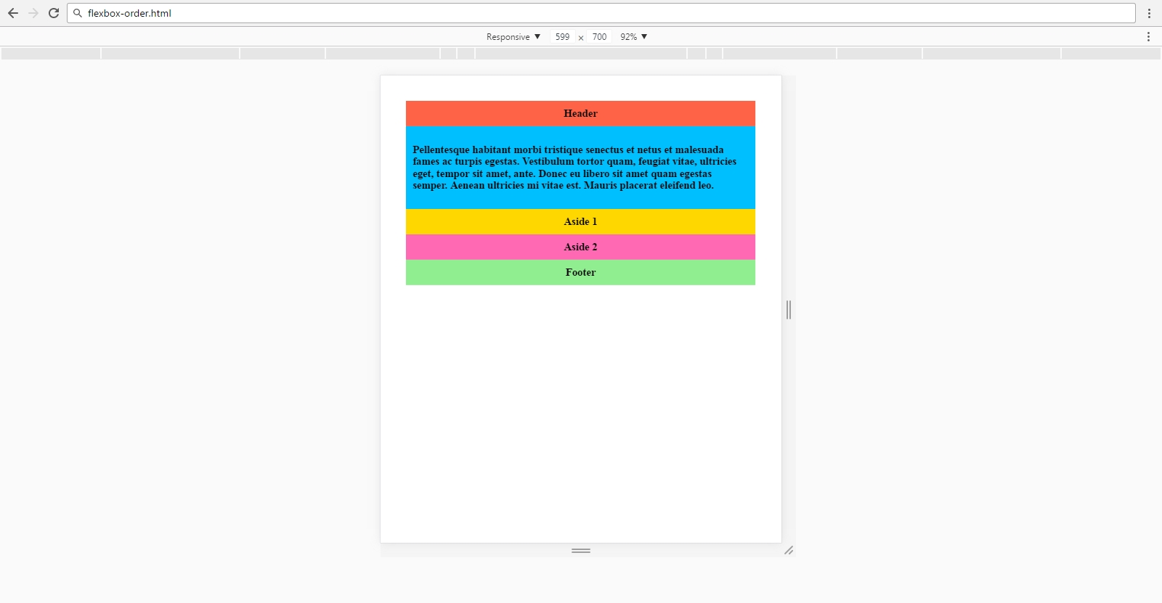

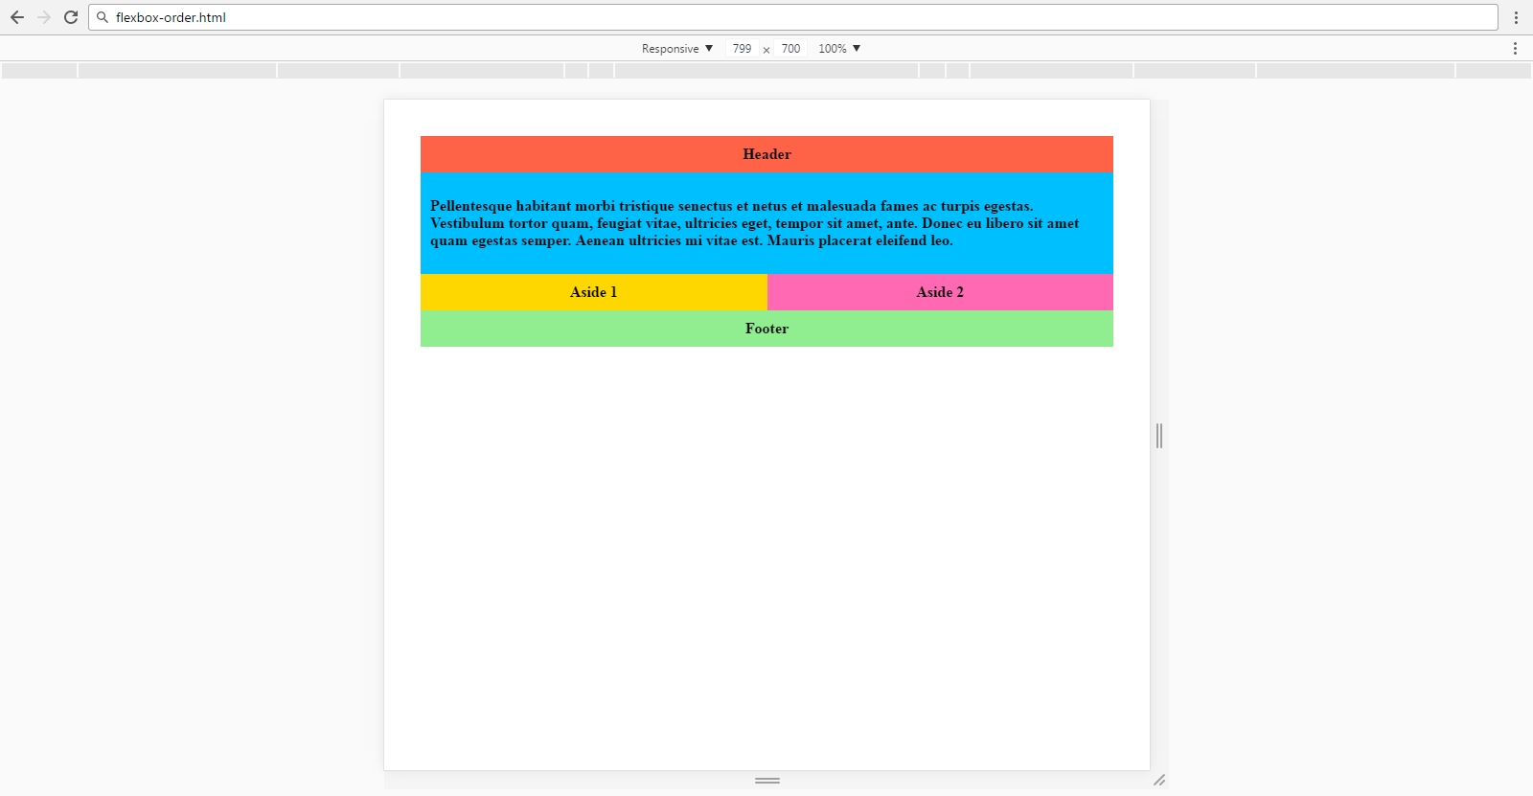

Create files: "**flexbox-order.css**"

### Steps to Follow

Start with the **site header**:

* body
  + Display: **flex**;
  + Flex-Flow: **row wrap;**
  + Font-Weight: Bold;
  + Center the text;
  + Padding: 30px;
* body > *
  + Padding 10px;
  + Flex: 1 100%;
* .header
  + Background: tomato;
* .footer
  + Background: lightgreen;
* .main-article
  + Text-Align: left;
  + Background: deepskyblue;
* .aside-1
  + Background: gold;
* .aside-2
  + Background: hotpink;

Test the site in the browser:

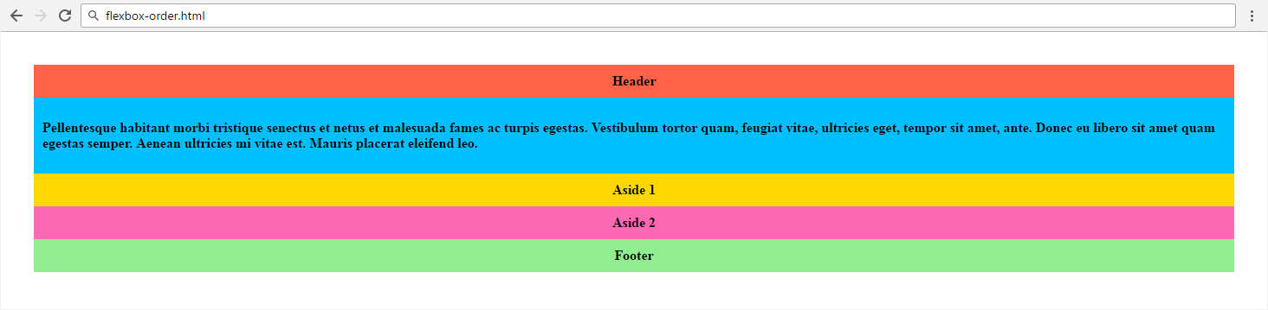

Now write the media queries

* @media all and (min-width: 800px)
  + .main-article { flex: 3 0; }
  + .aside-1 { order: 1; }
  + .main-article { order: 2; }
  + .aside-2 { order: 3; }
  + .footer { order: 4; }
* @media all and (min-width: 600px)
  + .aside { flex: 1 0; }

## Contact Form

You are given an unresponsive Web site (**HTML** + **CSS** + images). Your task is to **make the site responsive**. The site layout should change according to the browser viewport / screen size at **660px** and at **800px**. 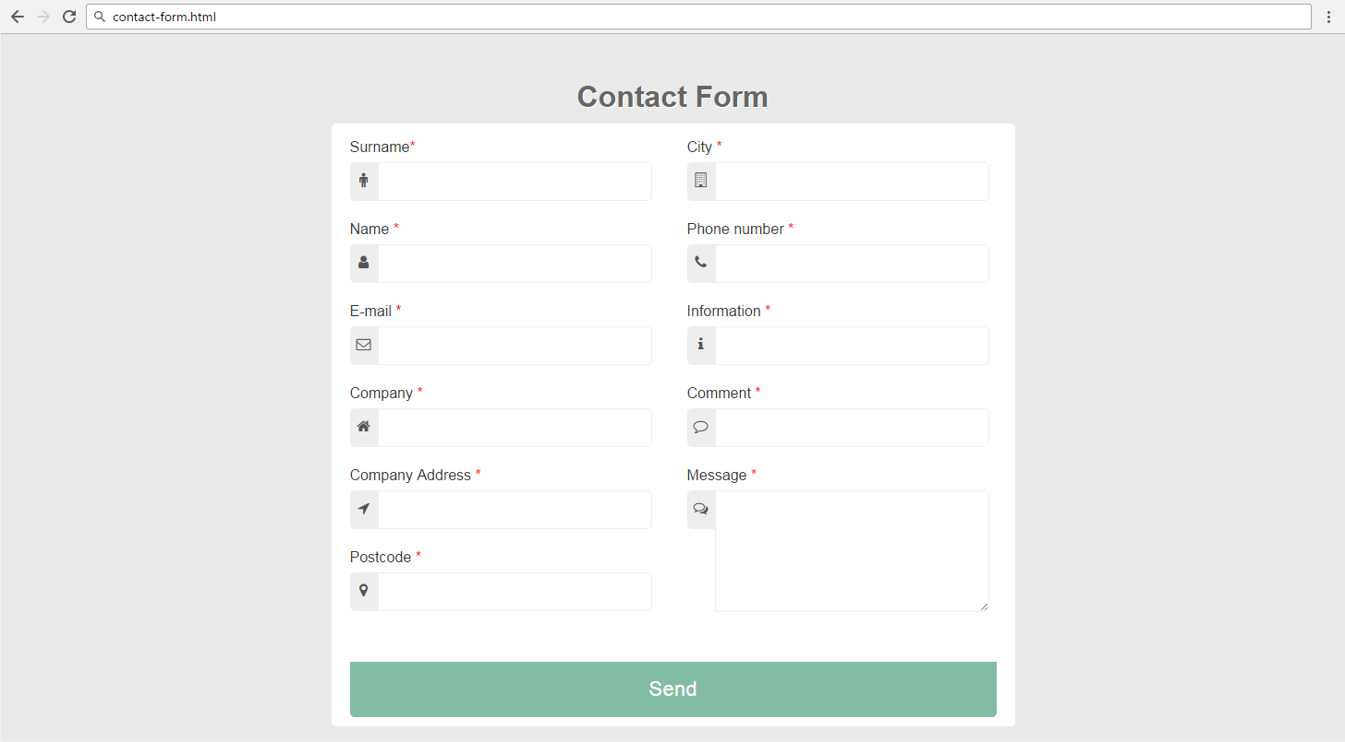

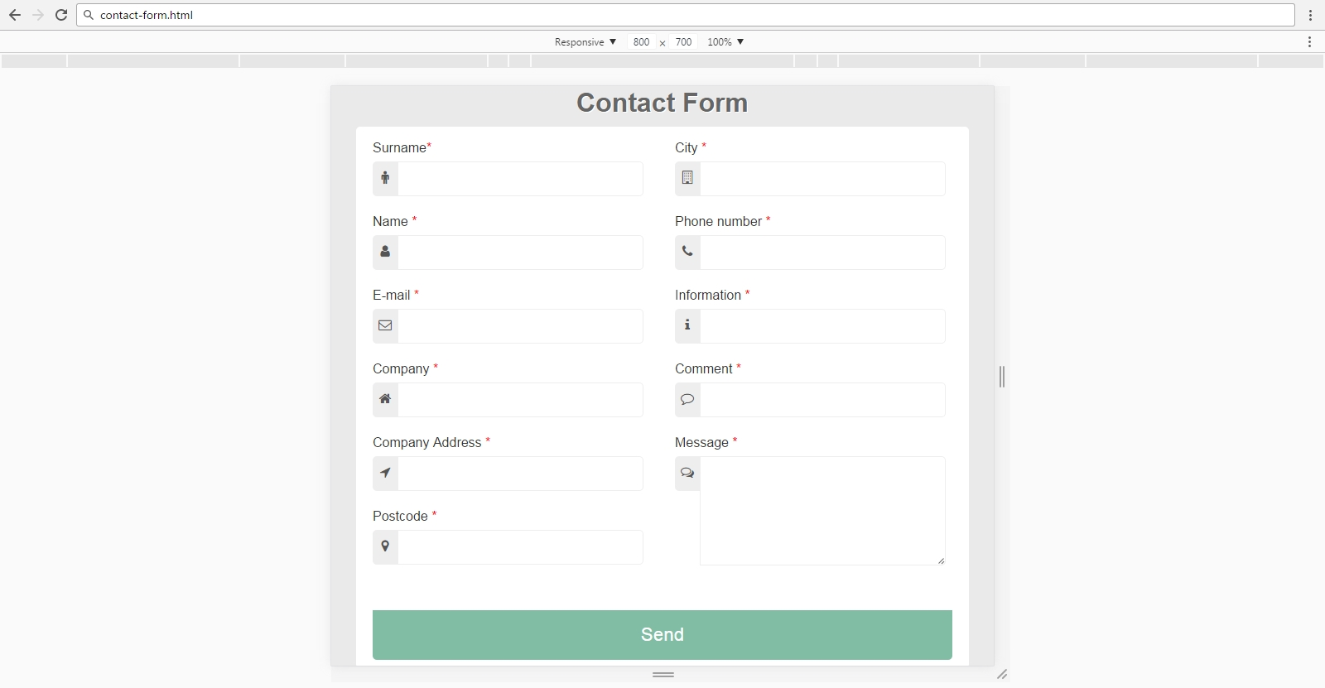

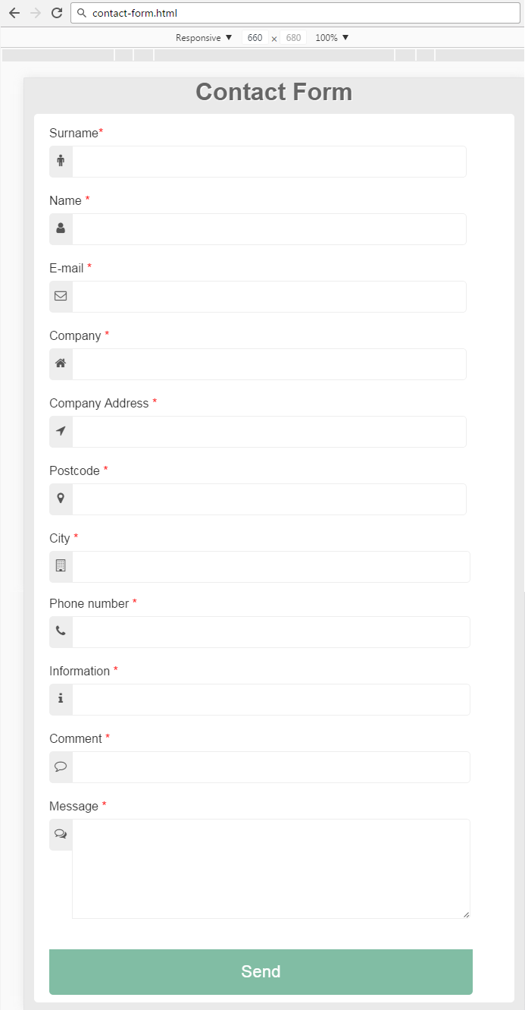

### Input

You are given the unresponsive site as HTML + CSS + images.

### Output

The output should be valid HTML5 + CSS3 + images that implement the above responsive site.

## Bank Credit

You are given an unresponsive Web site (**HTML** + **CSS** + images). Your task is to **make the site responsive**. The site layout should change according to the browser viewport / screen size at **600px.**

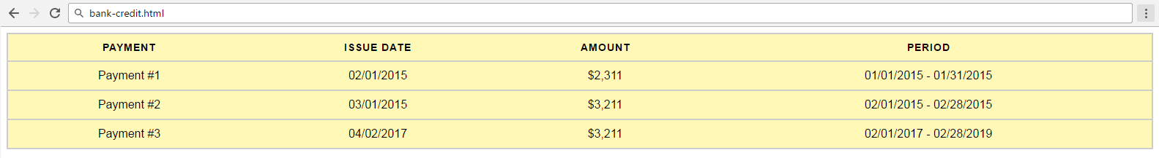

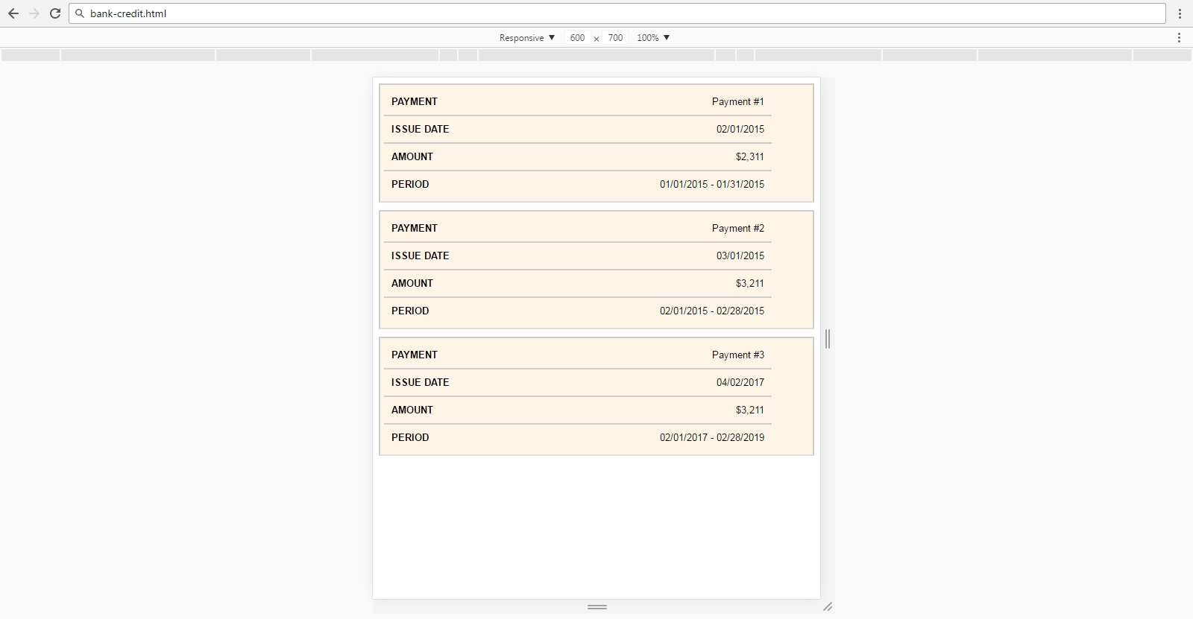

### Input

You are given the unresponsive site as HTML + CSS + images.

### Output

The output should be valid HTML5 + CSS3 + images that implement the above responsive site.

## HR Company

You are given an unresponsive Web site (**HTML** + **CSS** + images). Your task is to **make the site responsive**. The site layout should change according to the browser viewport / screen size at **880px**.

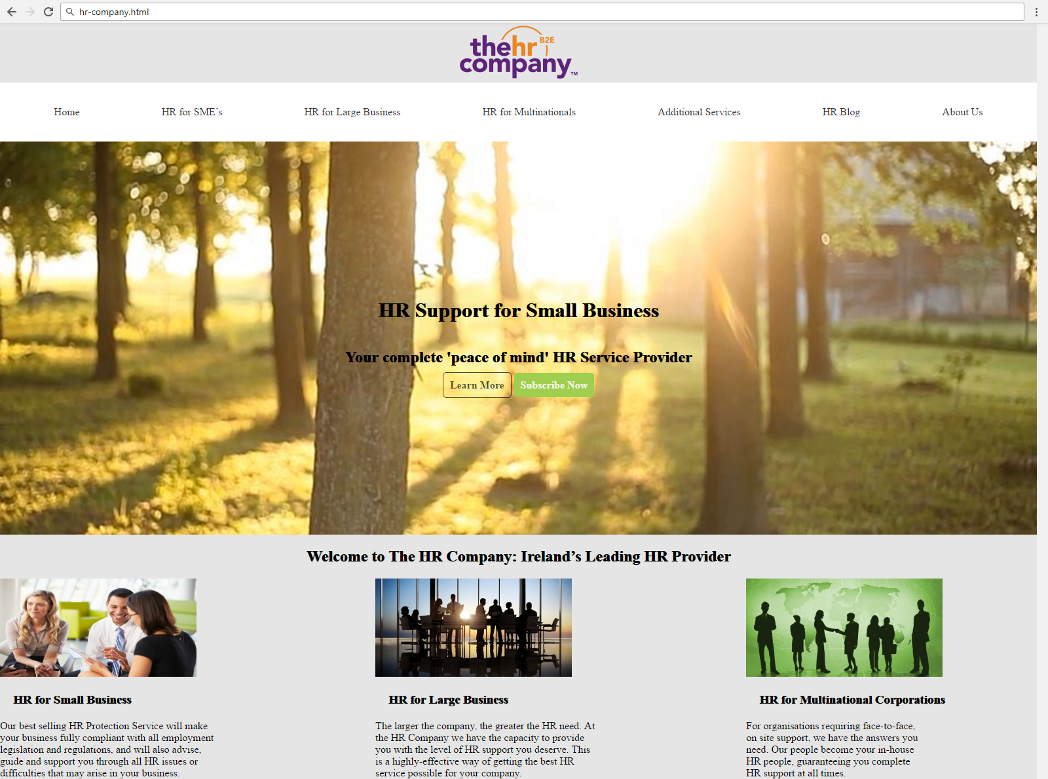



### Input

You are given the unresponsive site as HTML + CSS + images.

### Output

The output should be valid HTML5 + CSS3 + images that implement the above responsive site.